**Operating System**

**(CT-353)**

Lab no 02

1. FCFS CPU Scheduling Algorithm

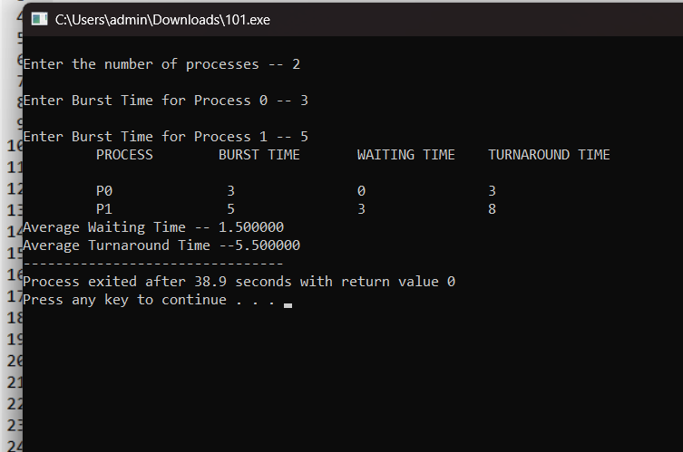

1. SJF CPU Scheduling Algorithm

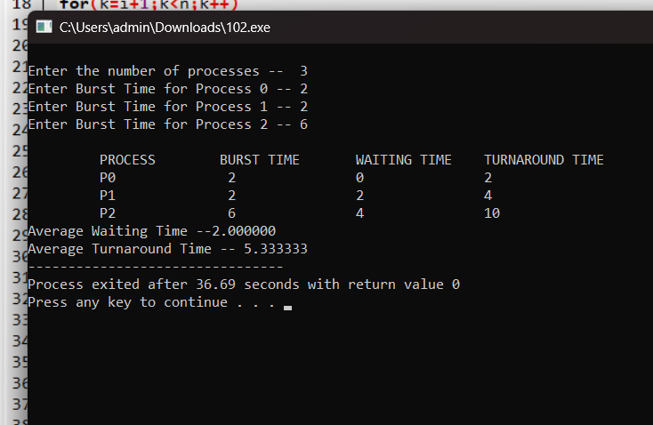

1. ROUND ROBIN CPU Scheduling Algorithm

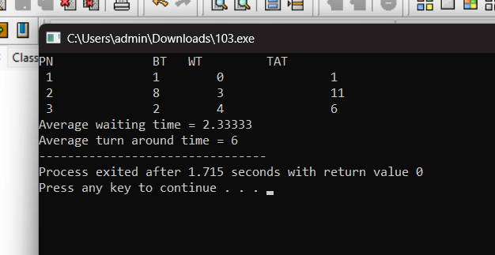

1. PRIORITY CPU Scheduling Algorithm

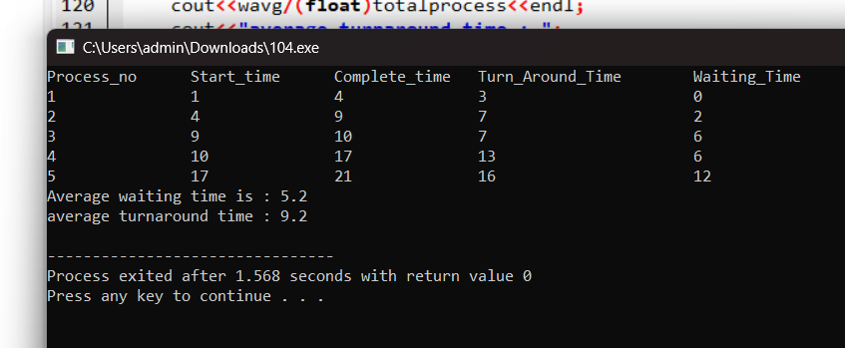

1. Execute all scheduling algorithms on following data and find out the Average Waiting Time and Average Turnaround Time of all scheduling algorithms and discuss your results. (Quantum Value is 3)

*FCFS CPU SCHEDULING ALGORITHM*

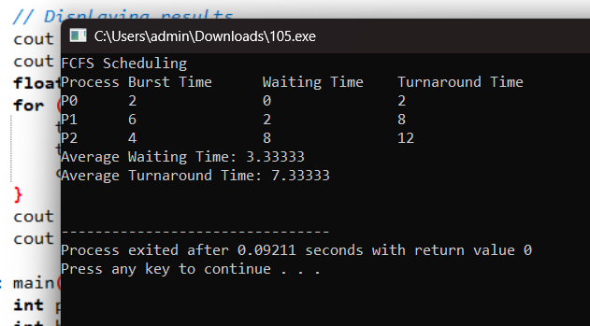

*SJF CPU SCHEDULING ALGORITHM*

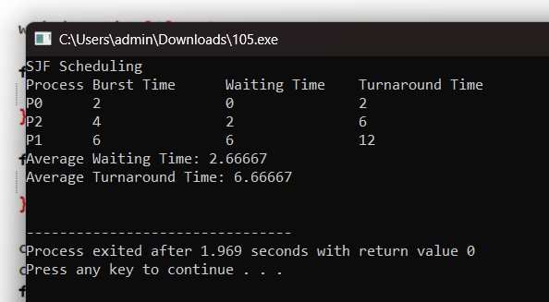

*PRIORITY CPU SCHEDULING ALGORITHM*

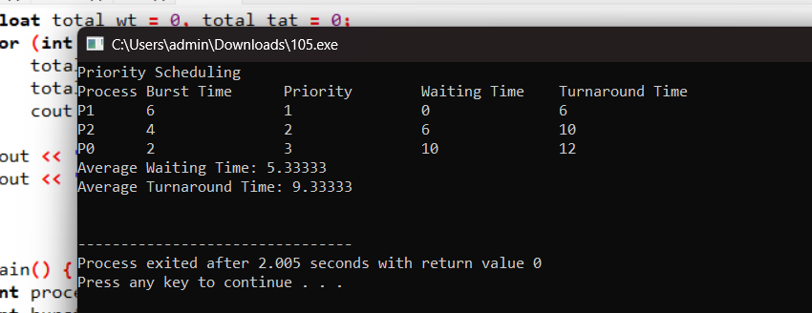

*ROUND ROBIN CPU SCHEDULING ALGORITHM*

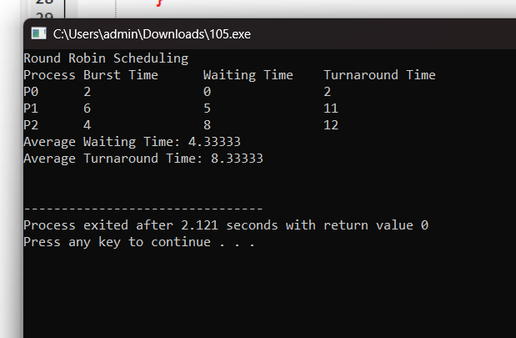

**Conclusion**

CPU scheduling algorithms prioritize processes in distinct ways. **First-Come, First-Served (FCFS)** executes tasks based on arrival order, potentially delaying lengthy ones. **Shortest Job First (SJF)** minimizes average waiting and turnaround times by prioritizing shorter tasks. **Priority Scheduling** focuses on tasks with higher importance, postponing those with lower priority. **Round Robin** ensures fairness via time slicing but may increase waiting time for short processes. Each method balances fairness, efficiency, and responsiveness differently.